Micro Service

creating Eureka Server project using spring initializer

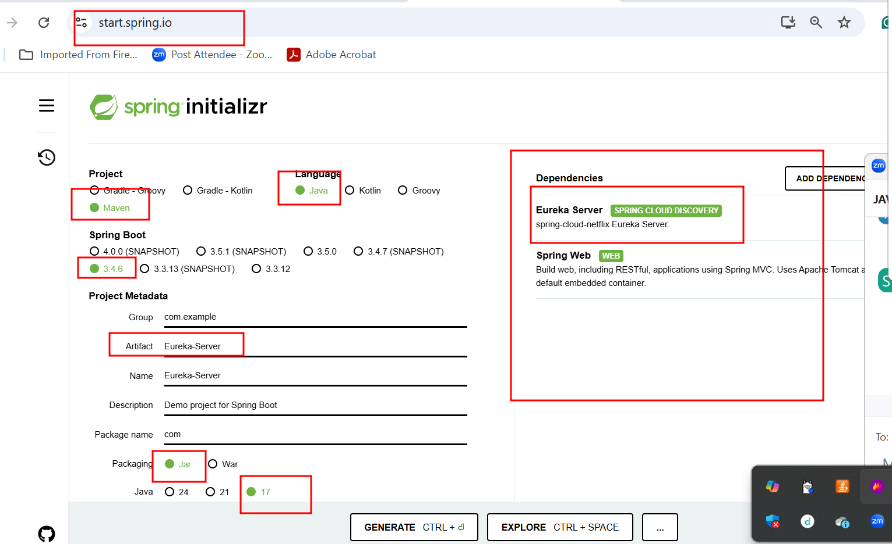

By default eureka server port number is 8761

micro service project as account micro service
- Create account -- Rest End Point using post
- FindBalance -- Rest End Point using get method passing as account id
- Find Account number - rest End point using get method passing emailid as unique key.

Starter - Web starter
Starter - JPA starter
Dependency - mysql connector
Starter - dev tools (whenever we do any changes in project automatically refresh the project).
Starter - Eureka discovery client
Port number 8282

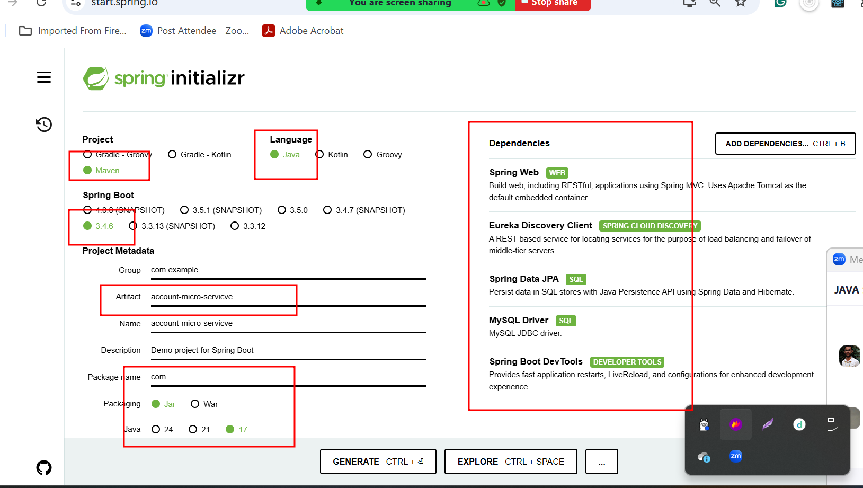

@RequestMapping annotation we can use on class level as well as method level.
Method level is use to map the path as well as request method like get, post ,put and delete.
Class level to provide root path.

Gapy Micro Service
This micro service running on port number 8383
Got to interact with Account micro service running on port number 8282 to get the account number once you pass emailid.
Gpay micro service use one the in build database provided by spring boot ie
H2 : H2 is in memory database. Which hold the data for temporary purpose.
Gpay : gpaid (PK) auto increment, accnonumber and emailid
Gpay micro service interact with account micro service to get the account number using emailid. If present it will create gpay account else it will display error message as account not exist not present.

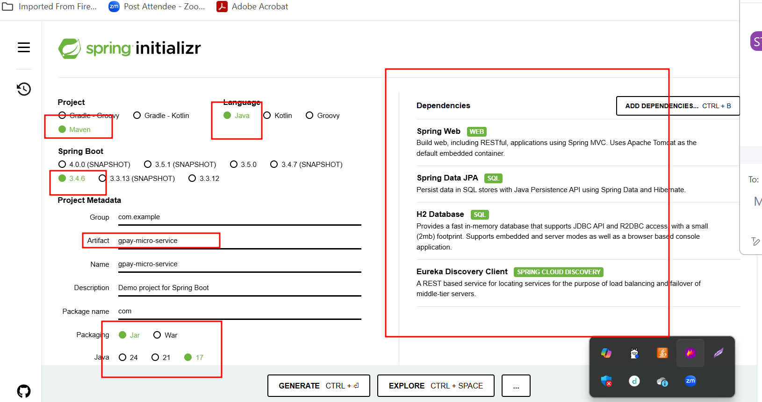

RestTemplate : is a pre defined API provided by spring boot which help to communicate one micro service to another micro service.
In spring boot Few API we can’t do auto wired by default. So some time object we need to create and maintain by spring boot.

Open H2 database using browser below URL
http://localhost:8383/h2-console

